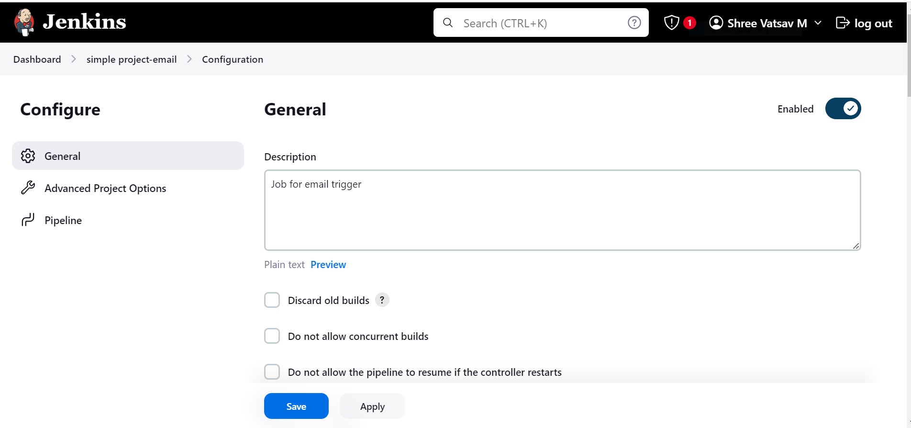

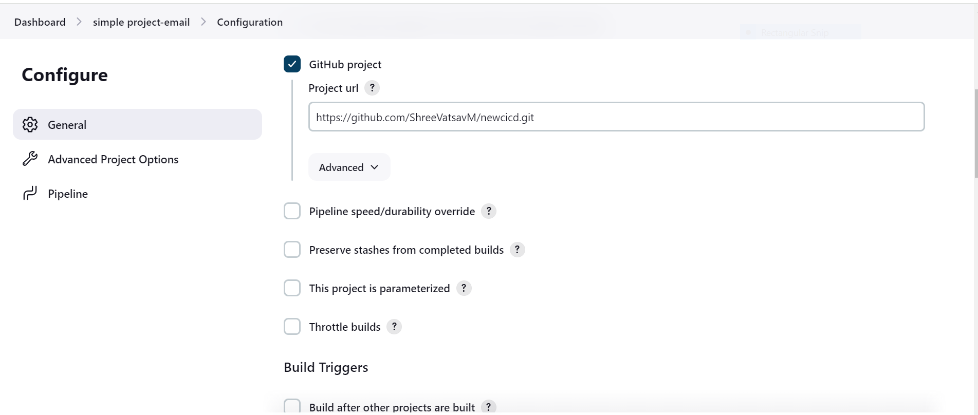

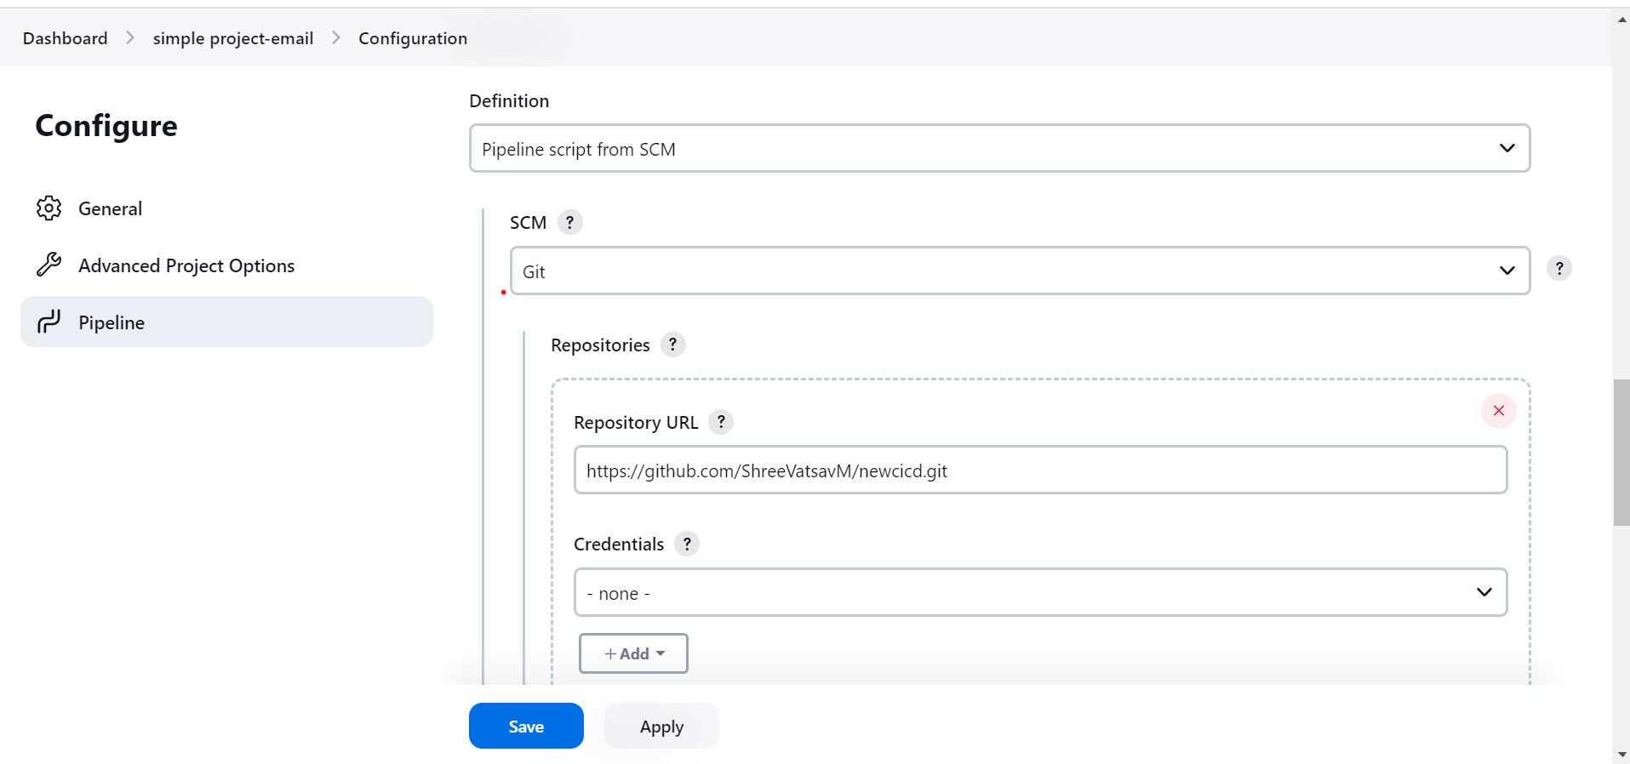

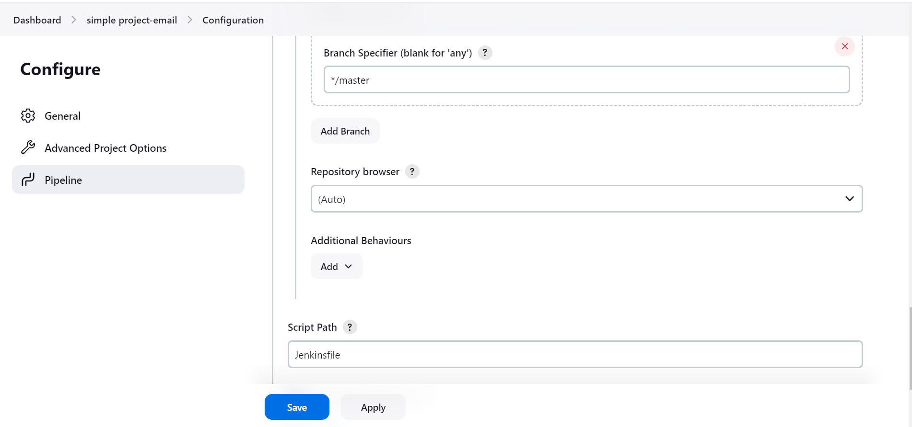

**INSTALL PLUGIN**

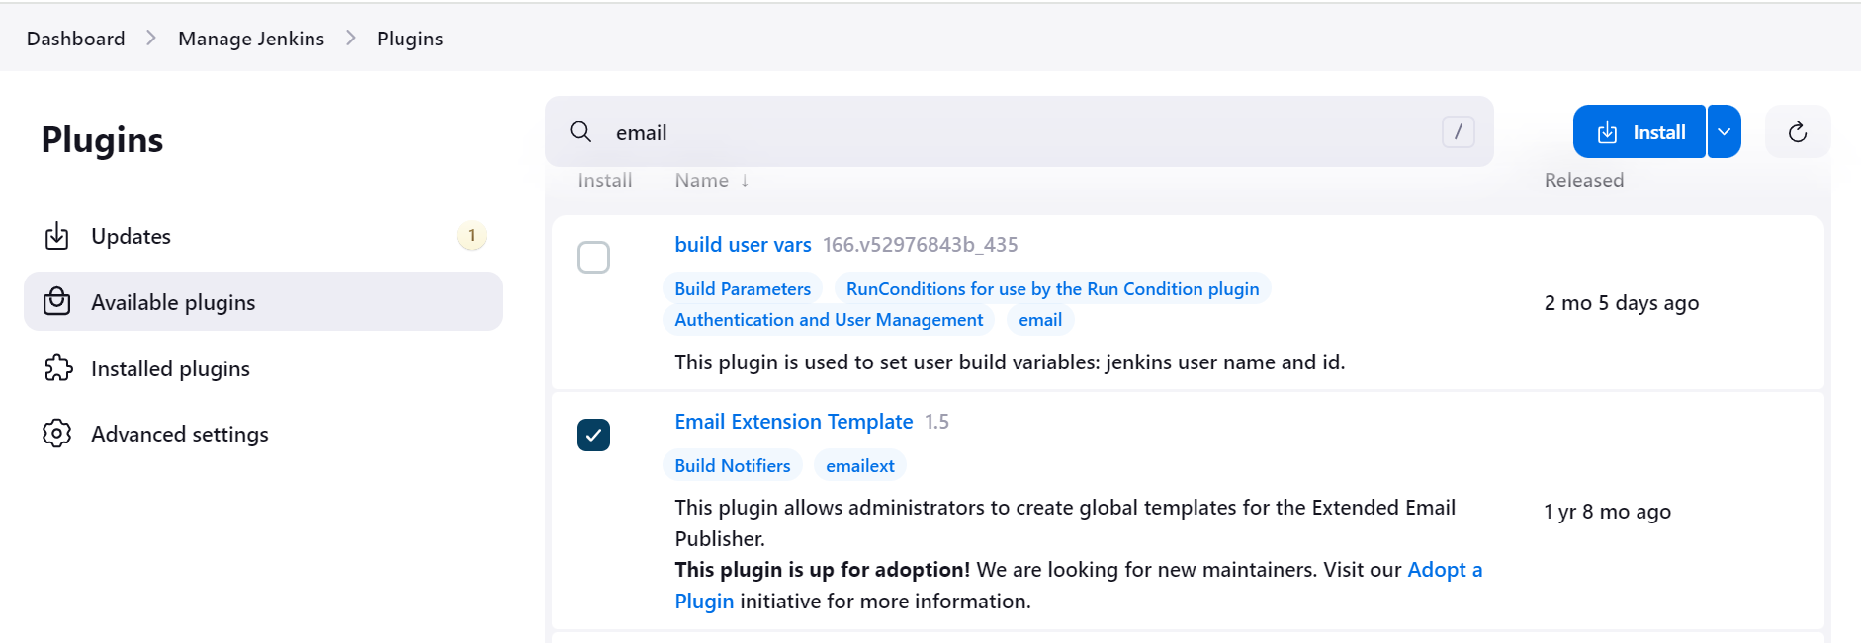

**ENVIRONMENTAL VARIABLE**

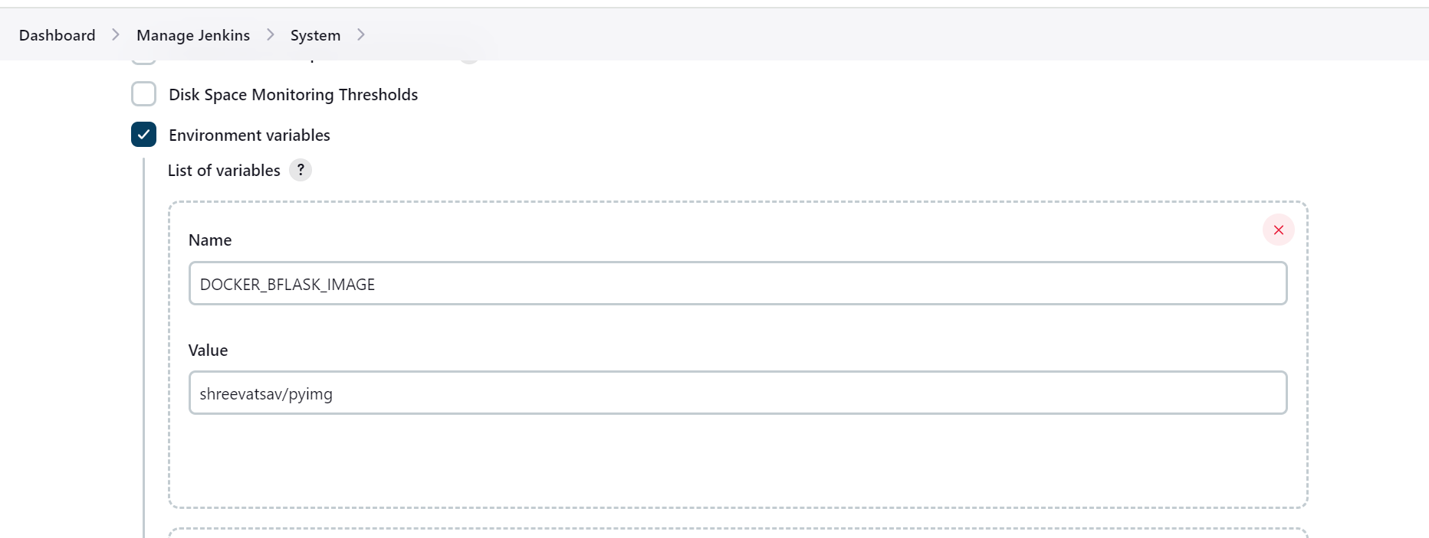

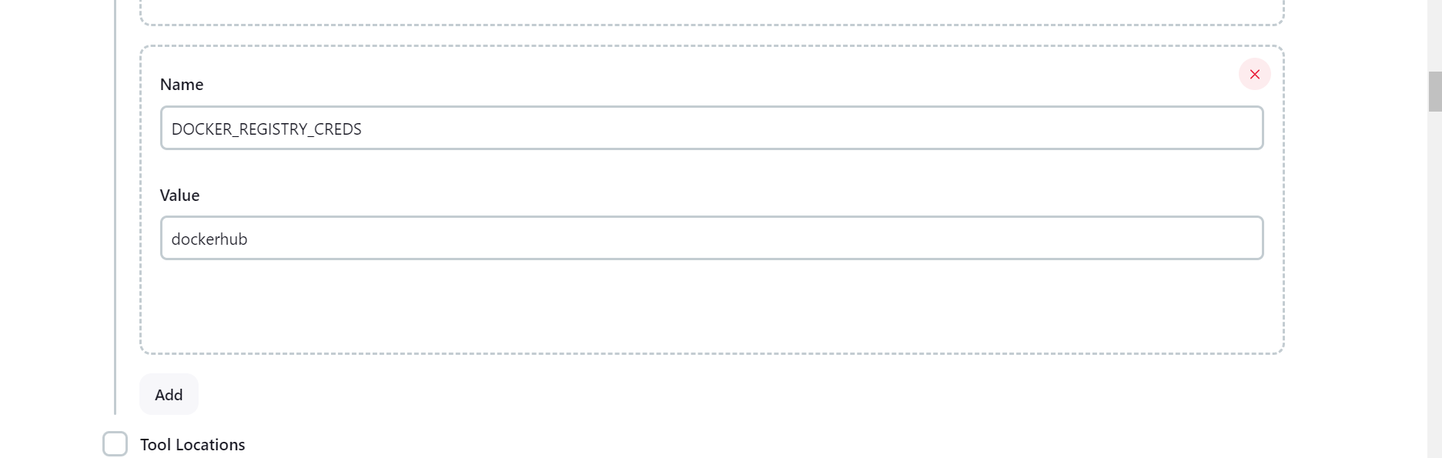

**EMAIL CONFIGURATION**

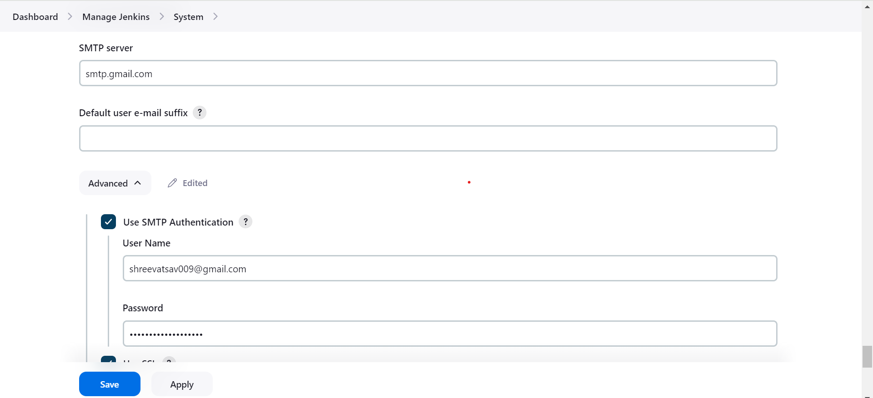

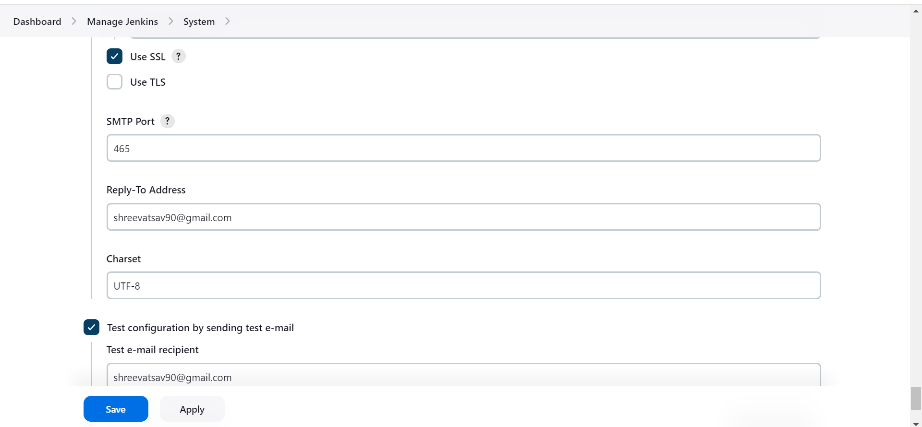

**GIVE AUTHENTICATION TO JENKINS IN GMAIL**

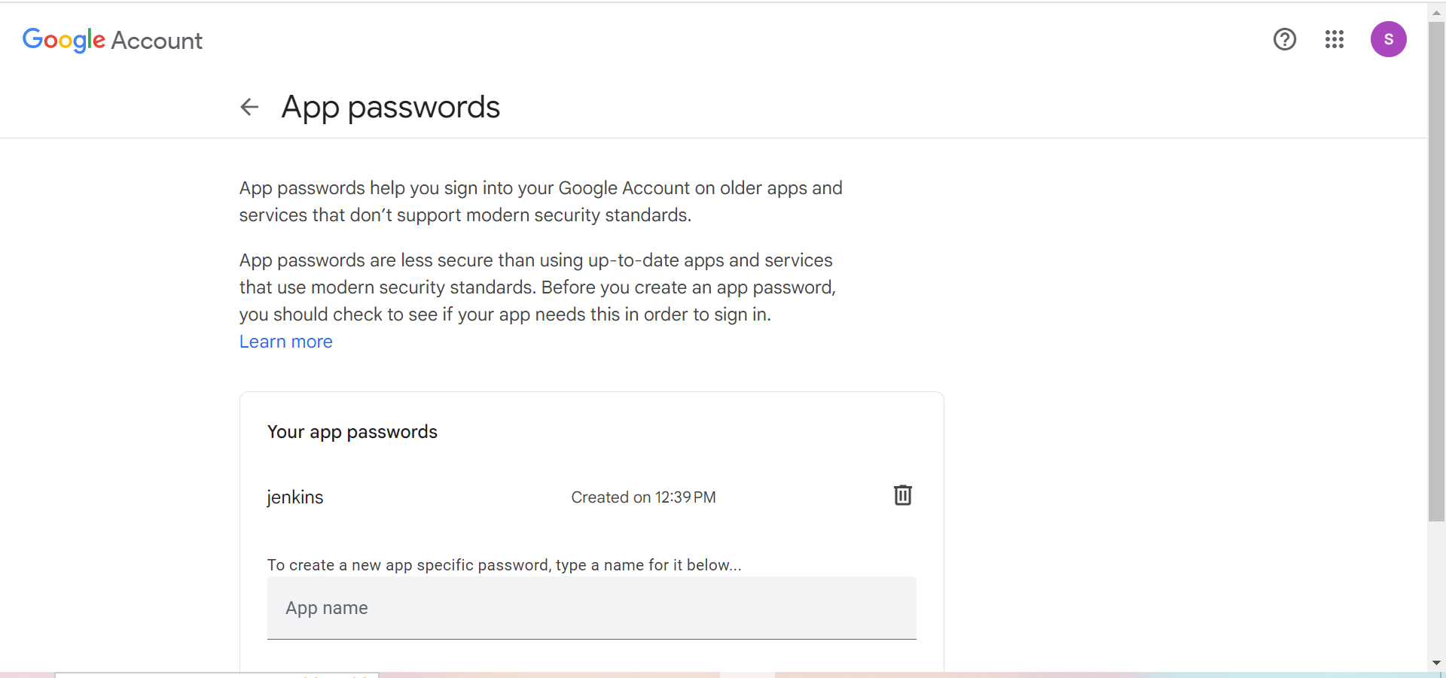

**CONSOLE OUTPUT**

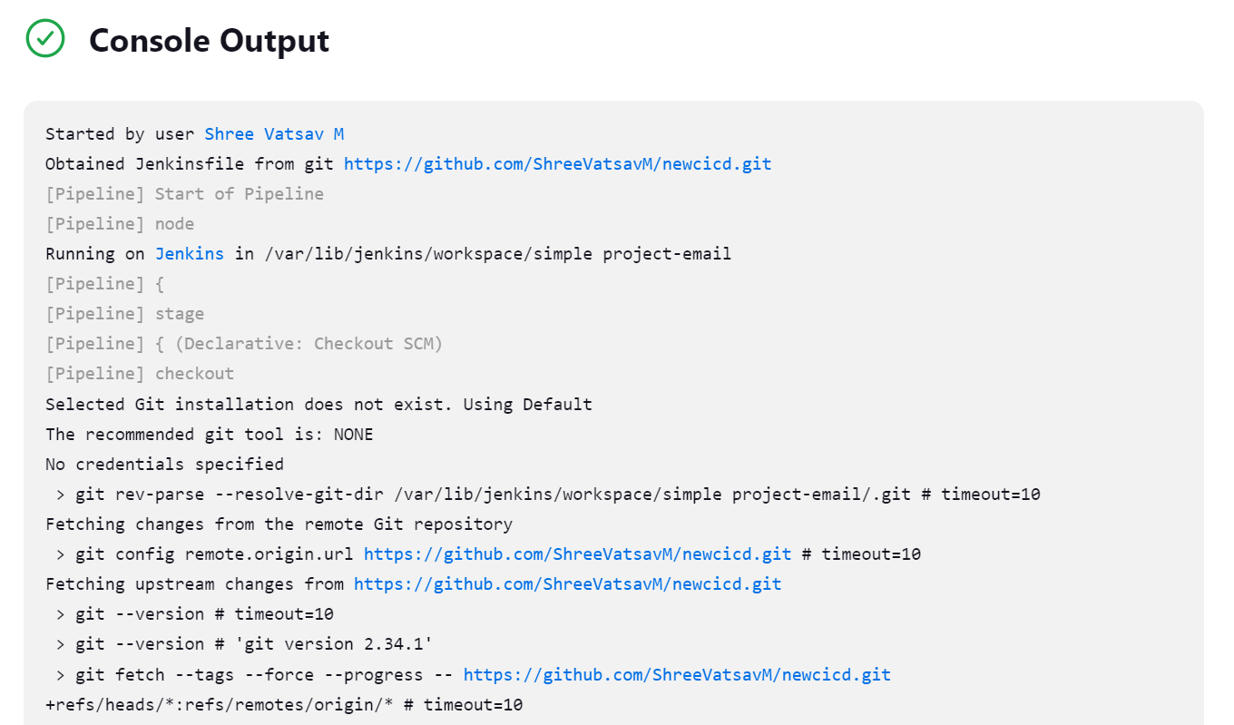

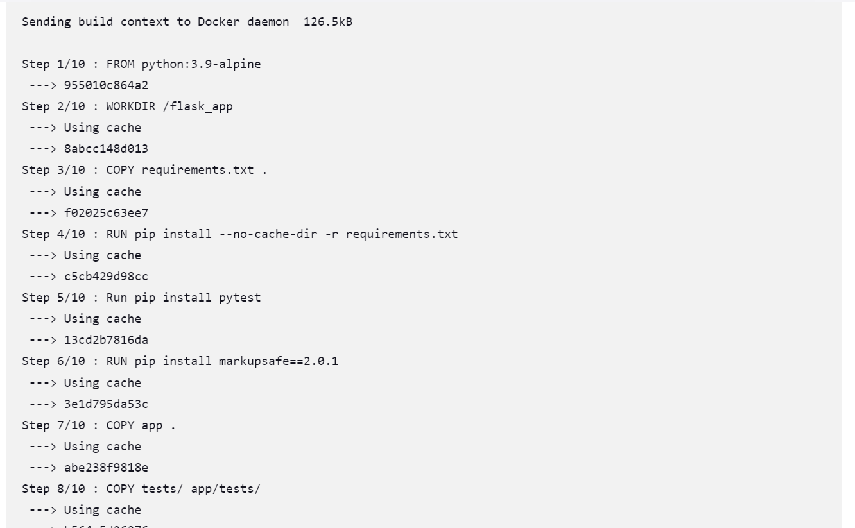

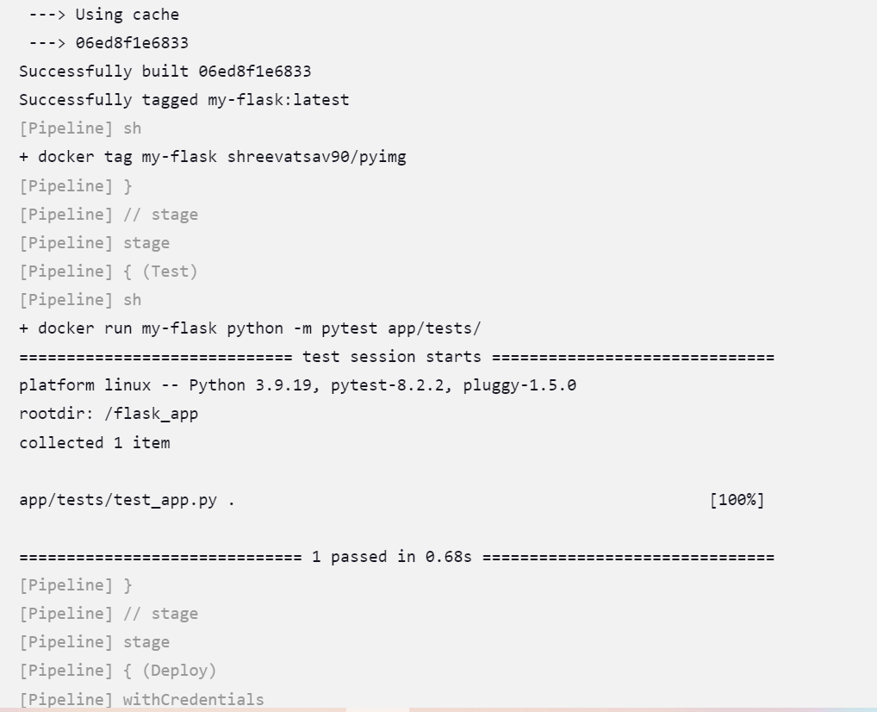

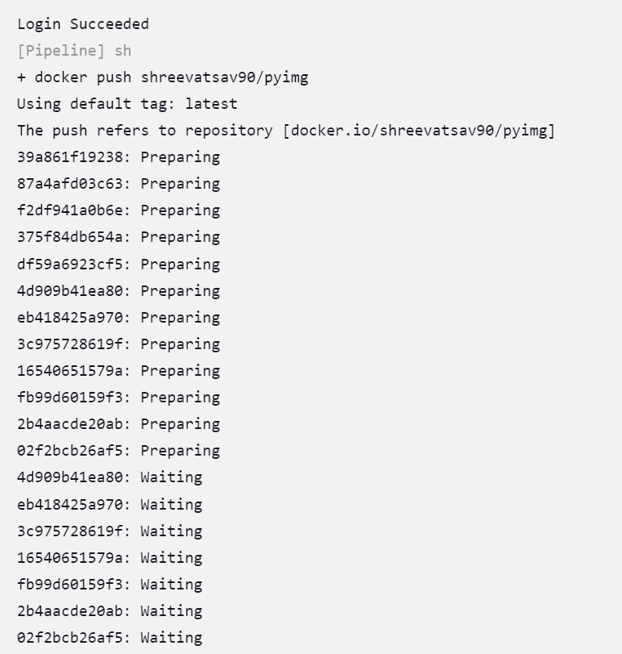

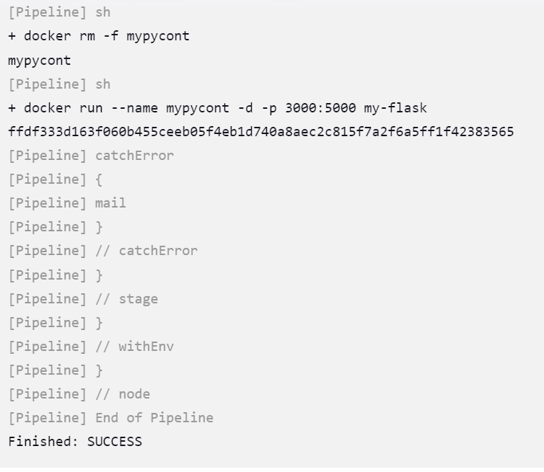

**AUTOMATE THE BUILD WHEN ANY CHANGES IS MADE**

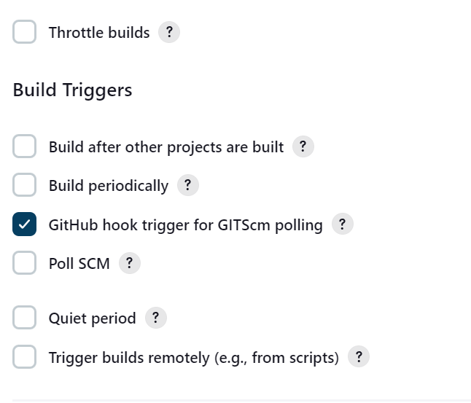

**ADD WEBHOOK IN GITHUB REPOSITORY**

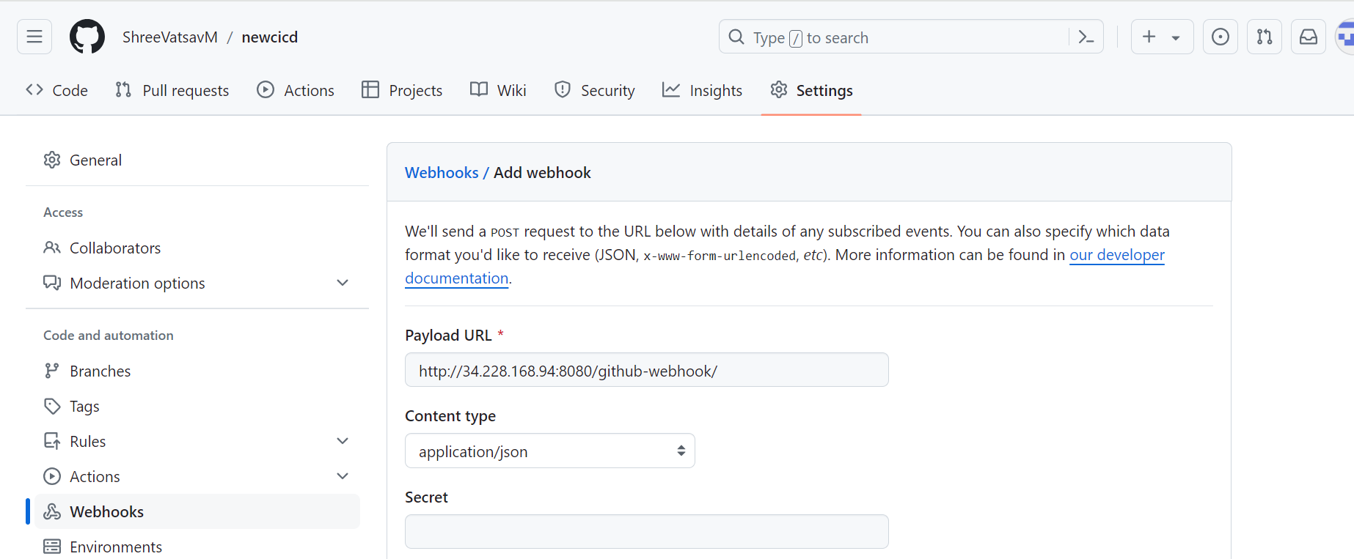

**NOW IF WE MAKE ANY CHANGES IN THE REPOSITORY , THE BUILD WILL AUTOMATICALLY WILL GET TRIGGRED AND EMAIL NOTIFICATION WILL ALSO BE SENT.**

**OUTPUT BEFORE CHANGES**

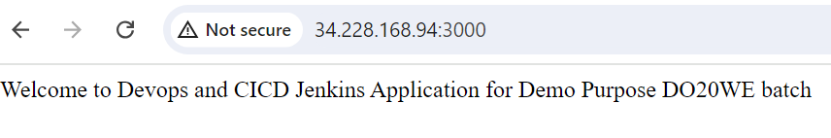

**OUTPUT AFTER CHANGES**

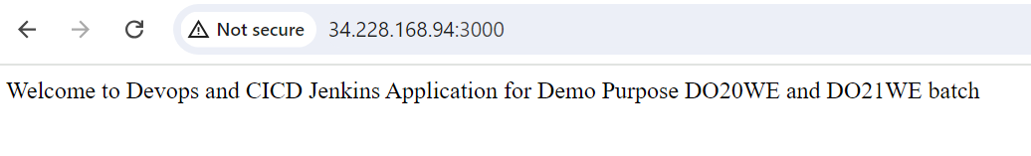

**EMAIL NOTIFICATION AFTER THE CHANGES**

